MINISTRY OF GENERAL EDUCATION
I/SCIENCE LESSON PLAN
NAME OF TEACHER:________________________ SCHOOL:_____________________
GRADE | TOPIC | SUB TOPIC | DURATION | DATE
8 | PLANTS AND ANIMALS | PLANT GROWTH & NUTRIENTS | ____min | ____/___/__
ATTENDANCE: Boys:______ Girls:_______ Total:_____
TEACHING/ LEARNING AIDS : Plants, Microscope, Chalk board, Learners books and Charts.
REFERENCES : I/Science Progress book 8
RATIONALE: This is lesson number two on Plants and Animals. It will help learners acquire skills and values of identifying the different types of Plant growth & nutrients. Group work, discussion, demonstration and Question & Answer methods will be used to execute the lesson.
PRE-REQUISITE SKILLS/ KNOWLEDGE: learners have ideas about the Plant and animals.
SPECIFIC OUTCOMES, LSBAT:
- Identify regions of growth of a plant
- Demonstrate responses to stimuli in shoots and roots
- List parts of a stimuli in shoots and roots
STAGE | CONTENT | TEACHERS ACTIVITY | PUPILS ACTIVITY | METHODS
INTRODUCTION  ____min | Recap on previous lesson  - Description of plants and animals in the environment  - The main parts of the microscope | Teacher asks random questions | Pupils respond and participate | Brainstorm
D  E  V  E  L  O  P  M  E  N  T  ___min | Regions of growth of a plant  - Shoot  - Roots  - Stem  Responses to stimuli in shoots and roots  Roots and shoots of plants determine the growth rate of a plant. These are dependent on the response of the root or shoot to external stimuli. Shoots respond to light. The response of shoots to light is called phototropism. The figure below illustrates the response of shoots to light.  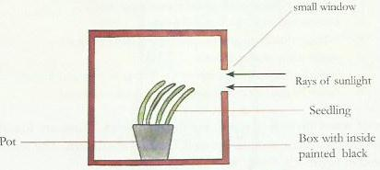  Note: The response of the root to light is negative and this is called negative phototropism Roots however, respond positively to gravity, hence they are positively geotropic. We call this response as positive geotropism. The response of roots to gravity is beneficial in that the plant is able to get fixated in the soil; it is able to absorb water and mineral salts.  Plant roots also respond to water the same way they respond to gravity. The response of plants to water is hydrotropism.  Experiment; To find out about geotropism in roots and stems using a newly germinated bean.  Materials: germinating bean seeds, beaker or glass jar, cotton wool.  Method - soak the cotton wool in water  - Place the cotton wool into the beaker.  - Place the germinating bean seeds between the walls of the beaker and soaked cotton wool so that they can be seen through the glass wall of the beaker.  - when positioning the seeds, arrange at a 45 angle so that their radicals (roots) point upwards and their plumules (shoots) point downwards  - Place in a warm, sunny place.  - Allow standing for three to five days. Ensure that the cotton wool is kept moist at all times  - draw your seed in the correct biological way  - Explain your results and observations  Observations/results  - The roots of the germinating seeds curve away from the top of the beaker and grow downwards.  - The shoots of the germinating seeds curve away from the bottom of the beaker and grow downwards.  The figure below illustrates predicted results for the experiment described above.  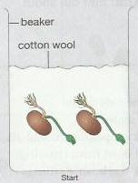  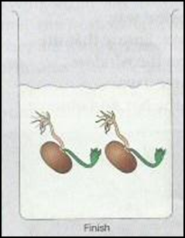  Conclusion  This shows that:  - The stems are negatively geotropic as the shoots are growing upwards (away from the earth)  - The roots are positively geotropic as they are growing downwards (towards the earth). | Teacher explains the details to the learners  Teacher puts pupils in groups to discuss | Pupils listen and ask questions where not clear  Pupils discuss and bring out points  . | Teachers  Exposition  Group  work
 | Lesson Conclusion  Teacher guiding learners in the practical activity (Experiments) | Teacher asks random questions | Learners respond to the questions | Question  &  Answer
Practical Activity
- Identify regions of growth of a plant
- Demonstrate responses to stimuli in shoots and roots
- List parts of a stimuli in shoots and roots
PUPIL’S EVALUATION
………………………………………………………………………………………………………
………………………………………………………………………………………………………
TEACHER’S EVALUATION
………………………………………………………………………………………………………

